RetinAI: AN AI-POWERED CNN-BASED SYSTEM FOR
MULTI-CLASS EYE DISEASE DETECTION AND
EXPLAINABLE DIAGNOSTIC REPORTING
MINI PROJECT REPORT
submitted in partial fulfillment of the requirements
for the award of the degree in
BACHELOR OF TECHNOLOGY
in
COMPUTER SCIENCE AND ENGINEERING(ARTIFICIAL INTELLIGENCE)
by
J SRI HARI 231211101346
K S V ABHINASH 231211101351
SIVA BHARATH 231211101289
DEPARTMENT OF
ARTIFICIAL INTELLIGENCE

AUGUST 2026

DEPARTMENT OF ARTIFICIAL INTELLIGENCE
BONAFIDE CERTIFICATE
This is to certify that this Mini Project Report titled “RetinAI: An AI-Powered CNN-Based System for Multi-Class Eye Disease Detection and Explainable Diagnostic Reporting” is the bonafide work of Mr. J SRI HARI (231211101346), Mr. K S V ABHINASH (231211101351), and Mr. SIVA BHARATH (231211101289), who carried out the Mini Project under our supervision from February 2026 to July 2026.

Project coordinator Department Head
Mr. C.BALAJI Dr. S.GEETHA
Professor Professor & Head
Department of CSE-AI Department of CSE
Dr. MGR Educational and Research Institute Dr. MGR Educational and Research Institute Maduravoyal, Chennai Maduravoyal, Chennai

Submitted for Viva Voce Examination held on …………………………………

Internal Examiner External Examiner

ACKNOWLEDGEMENT
We would first like to thank our beloved Founder Chancellor Thiru. Dr. A.C. SHANMUGAM, B.A., B.L., President Er. A.C.S. ARUNKUMAR, B.Tech., M.B.A., and Secretary Thiru A. RAVIKUMAR for the encouragement and support extended to us during the tenure of this project and throughout our years of study at this University.

We express our heartfelt thanks to our Vice Chancellor Prof. Dr. S. GEETHALAKSHMI for providing all the support required for our Mini Project.
We express our heartfelt thanks to our Dean and Head of the Department Prof. Dr. S. GEETHA, who has been actively involved and very influential from the start till the completion of our mini project.

Our sincere thanks to our Mini Project Coordinators Mr. C BALAJI for their continuous guidance and encouragement throughout this work, which has made the project a success.

We would also like to thank all the teaching and non-teaching staff of the Department of Computer Science and Engineering for their constant support and encouragement while we worked towards achieving our project goals.

TABLE OF CONTENTS
S. No. | CONTENT | PAGE NO.
 | BONAFIDE CERTIFICATE
 | ACKNOWLEDGEMENT
 | MAJOR DESIGN CONSTRAINTS AND DESIGN STANDARDS
 | ABSTRACT | i
 | LIST OF TABLES | ii
 | LIST OF FIGURES | iii
 | LIST OF SYMBOLS, ABBREVIATIONS AND NOMENCLATURE | iv
1 | INTRODUCTION | 1
1.1 | Broad Area of the Project | 1
1.2 | Problem Statement | 1
1.3 | Motivation | 1
1.4 | Ethical, Social and Professional Issues | 1
1.4.1 | Ethical Considerations | 1
1.4.2 | Social Considerations | 2
1.4.3 | Professional and Data-Privacy Considerations | 2
2 | LITERATURE SURVEY | 3
2.1 | Machine Learning and Deep Learning for Medical Imaging | 3
2.2 | Related Work on CNN-Based Eye Disease Classification | 3
2.3 | Explainable AI in Medical Image Classification | 4
2.4 | Research Gap | 4
3 | EXISTING SYSTEM | 5
3.1 | Overview of Current Screening Practice | 5
3.2 | Existing Automated Screening Tools | 5
3.3 | Limitations of Existing Approaches | 5
3.4 | Need for the Proposed System | 5
4 | PROPOSED SYSTEM | 6
4.1 | Overview | 6
4.2 | System Architecture | 6
4.3 | Image Preprocessing and Inference Pipeline | 6
4.4 | Diagnostic Classes | 7
4.5 | Explainability: Grad-CAM | 7
4.6 | UML Perspective | 8
4.7 | Standards Used | 10
5 | SYSTEM SPECIFICATION | 11
5.1 | Hardware Specification | 11
5.2 | Software Specification | 11
5.3 | Datasets and Split Strategy | 12
6 | IMPLEMENTATION | 13
6.1 | Application Workflow | 13
6.2 | Model Loading and Inference | 13
6.3 | Preprocessing Implementation | 13
6.4 | Diagnosis and Clinical Insight Generation | 14
6.5 | Grad-CAM Overlay | 14
6.6 | Analytics Dashboard and Report Export | 14
6.7 | Application Screenshots | 14
7 | RESULT AND CONCLUSION | 18
7.1 | Results | 18
7.2 | Discussion | 19
7.3 | Conclusion | 19
7.4 | Future Work | 19
 | REFERENCES | 20

MAJOR DESIGN CONSTRAINTS AND DESIGN STANDARDS
Field | Details
Student Group | J SRI HARI 231211101346  K S V ABHINASH 231211101351  SIVA BHARATH 231211101289
Project Title | VisionCheck: An AI-Powered CNN-Based System for Multi-Class Eye Disease Detection and Explainable Diagnostic Reporting
Program Concentration Area | Medical Image Analysis, Deep Learning, Computer Vision, Web-Based Healthcare Applications
Constraints Examples | Variability in fundus/OCT image quality (illumination, resolution, noise); limited compute for real-time browser-based inference; class imbalance across seven diagnostic categories; need for model interpretability in a clinical setting; privacy of patient images and scan history
Economic | Yes
Environmental | Yes
Sustainability | Yes
Implementable | Yes
Ethical | Yes
Health and Safety | Yes
Social | Yes
Political | NA
Other | NA
Standards | - IEC 62304 – Medical Device Software Life-Cycle Processes  - ISO/IEC 25010 – Systems and Software Quality Requirements and Evaluation (SQuaRE)  - IEEE 830 – Recommended Practice for Software Requirements Specifications  - ISO/IEC 27001 – Information Security Management Systems  - HIPAA / India's Digital Information Security in Healthcare Act (DISHA) — health data privacy guidelines

Prerequisite Courses for the Mini Project
- Machine Learning
- Deep Learning / Neural Networks
- Digital Image Processing
- Python Programming
- Web Technologies

ABSTRACT
Eye diseases such as diabetic retinopathy, glaucoma, cataract, and age-related macular degeneration are among the leading causes of preventable blindness worldwide, and early detection is critical to limiting irreversible vision loss. In many regions, however, access to a qualified ophthalmologist for routine retinal screening remains limited, creating a strong case for automated, AI-assisted pre-screening tools. This project presents VisionCheck, a browser-based, deep-learning-driven system that classifies retinal, fundus, OCT, and iris images into seven diagnostic categories: diabetic retinopathy, cataract, glaucoma, age-related macular degeneration, conjunctivitis, retinal detachment, and normal (no pathological finding).
The system uses a convolutional neural network (CNN) built on transfer learning, with EfficientNetB0 and ResNet50 as candidate base architectures fine-tuned on a combination of the ODIR, EyePACS, MESSIDOR-2, Kaggle DR, STARE, and DRIVE datasets, and a lightweight MobileNetV2 model as a fallback for constrained, client-side inference. Input images undergo a preprocessing pipeline consisting of resizing to 224×224, Contrast Limited Adaptive Histogram Equalization (CLAHE), noise reduction, normalisation, and augmentation before being passed through the network. To make the model's predictions interpretable to clinicians, the system incorporates Gradient-weighted Class Activation Mapping (Grad-CAM), which highlights the retinal regions that most influenced a given diagnosis.
Beyond classification, VisionCheck generates a structured clinical insight report for each prediction — covering probable causes, risk factors, symptoms, evidence-informed treatment options, preventive precautions, and a specialist-referral recommendation — along with a confidence score and a probability distribution across all seven classes. An analytics dashboard summarises disease distribution, confidence trends, severity breakdown, and model performance metrics (accuracy, precision, recall, F1-score, specificity, and AUC-ROC) across a user's scan history. The prototype achieves an overall validation accuracy of approximately 79% using the EfficientNetB0/ResNet50 configuration.
The system is explicitly positioned as a preliminary screening aid rather than a diagnostic replacement, with a persistent medical disclaimer directing users to a qualified ophthalmologist for confirmation. All image processing in the deployed client-side demonstration is performed locally in the browser using TensorFlow.js, without transmitting patient images to an external server, in keeping with privacy-by-design principles relevant to healthcare data. This report documents the motivation, literature background, system design, implementation, and evaluation of the VisionCheck system, and outlines directions for extending it toward clinical-grade deployment.

LIST OF TABLES
Table 2.1 Summary of Related Work on CNN-Based Retinal Disease Classification 16
Table 4.1 Summary of the Seven Diagnostic Classes and Severity Levels 24
Table 5.1 Hardware Specification 29
Table 5.2 Software Specification 30
Table 5.3 Dataset Summary and Train/Validation/Test Split 31
Table 7.1 Model Performance Metrics (MobileNetV2 Configuration) 38

LIST OF FIGURES
Fig. 4.1 – System Architecture of the Proposed Eye Disease Detection System Page 6
Fig. 4.2 – Image Preprocessing and CNN Inference Pipeline Page 7
Fig. 4.3 – Use Case Diagram Page 8
Fig. 4.4 – Class Diagram Page 9
Fig. 4.5 – Activity Diagram Page 9
Fig. 4.6 – Sequence Diagram Page 10
Fig. 6.1 – Application Workflow — Upload, Analyse, and View Results Page 13
Fig. 6.2 – RetinAI Home / Scan Interface Page 15
Fig. 6.3 – Image Upload Interface Page 15
Fig. 6.4 – Preprocessing and CNN Architecture Page 16
Fig. 6.5 – Eye Image Upload and Analysis Page 16
Fig. 6.6 – Diagnostic Result and Clinical Report Page 17
Fig. 6.7 – Analytics and Class Probability Distribution Page 17
Fig. 7.1 – Class Probability Distribution for a Sample Prediction Page 18

LIST OF SYMBOLS, ABBREVIATIONS AND NOMENCLATURE
AI Artificial Intelligence
AMD Age-related Macular Degeneration
API Application Programming Interface
AUC-ROC Area Under the Receiver Operating Characteristic Curve
CLAHE Contrast Limited Adaptive Histogram Equalization
CNN Convolutional Neural Network
DR Diabetic Retinopathy
Grad-CAM Gradient-weighted Class Activation Mapping
HbA1c Glycated Haemoglobin
IOP Intraocular Pressure
OCT Optical Coherence Tomography
ODIR Ocular Disease Intelligent Recognition (dataset)
ReLU Rectified Linear Unit
UML Unified Modelling Language
VEGF Vascular Endothelial Growth Factor

1. INTRODUCTION

1.1 BROAD AREA OF THE PROJECT
The project falls within the broad area of medical image analysis using deep learning, specifically the application of convolutional neural networks (CNNs) to ophthalmic screening. It combines elements of computer vision, transfer learning, explainable artificial intelligence (XAI), and web-based healthcare application design to build an end-to-end system that can classify eye images into clinically relevant categories and present the result in a form that is useful to both patients and clinicians.

1.2 PROBLEM STATEMENT
Vision-threatening eye diseases such as diabetic retinopathy, glaucoma, and age-related macular degeneration are frequently asymptomatic in their early, most treatable stages. Effective management therefore depends on regular screening, but comprehensive manual screening — reading retinal photographs one by one — does not scale to the size of at-risk populations, particularly in regions with a shortage of ophthalmologists. The problem addressed by this project is: how can a lightweight, browser-deployable CNN-based system provide a reasonably accurate, explainable, and privacy-preserving preliminary classification of common eye diseases from a single fundus, OCT, retinal, or iris image, to support (not replace) clinical triage?

1.3 MOTIVATION
The motivation for this work is threefold. First, the global burden of preventable blindness continues to rise alongside the prevalence of diabetes and an ageing population, and automated screening tools have been shown in the literature to meaningfully extend the reach of eye-care services. Second, recent CNN architectures such as EfficientNet, ResNet, and MobileNet, combined with transfer learning on ImageNet weights, make it feasible to reach clinically useful accuracy without training a network from scratch or requiring a very large, institution-specific dataset. Third, deep learning models are frequently criticised as "black boxes"; incorporating Grad-CAM-based visual explanations directly addresses the trust and interpretability gap that has historically limited clinical adoption of AI screening tools.

1.4 ETHICAL, SOCIAL AND PROFESSIONAL ISSUES

1.4.1 Ethical considerations
A screening tool of this kind carries a direct risk of harm if it is mistaken for a diagnostic instrument. The system therefore treats every prediction as a preliminary screening signal, displays a persistent medical disclaimer, and always recommends referral to a qualified ophthalmologist rather than presenting a confirmed diagnosis.

1.4.2 Social considerations
By running entirely in a web browser and requiring only a camera or an uploaded image, the system is designed to lower the barrier to a first-level screening, which is particularly relevant in under-served or rural settings where ophthalmology appointments may be scarce or costly.

1.4.3 Professional and data-privacy considerations
Retinal images can be linked to a patient's health status and, in some cases, identity, so the system is designed around a privacy-by-design principle: image processing in the client-side prototype is performed locally in the browser using TensorFlow.js, and scan history is kept only for the duration of the session unless the user explicitly opts into persistent storage through the backend API.

2. LITERATURE SURVEY

2.1 MACHINE LEARNING AND DEEP LEARNING FOR MEDICAL IMAGING
Classical machine learning approaches to retinal image analysis relied on handcrafted features — vessel tortuosity, microaneurysm counts, optic-cup-to-disc ratio — passed to classifiers such as SVMs or random forests. These pipelines were labour-intensive to engineer and did not generalise well across imaging devices. The introduction of deep CNNs, and in particular the demonstration that ImageNet-pretrained networks could be fine-tuned on comparatively small medical datasets through transfer learning, shifted the field toward end-to-end learned feature extraction and substantially improved reported accuracies across diabetic retinopathy, glaucoma, and cataract detection tasks.

2.2 RELATED WORK ON CNN-BASED EYE DISEASE CLASSIFICATION
A number of studies have investigated CNN-based classification of one or more eye diseases from fundus photographs. Table 2.1 summarises representative work relevant to this project.
Ref. | Approach | Dataset(s) | Reported Result
Khalifa et al. (2019) | Deep transfer learning (AlexNet, ResNet18, SqueezeNet, GoogLeNet, VGG16/19) | APTOS 2019 | Comparative accuracy across CNN backbones for DR detection
Jabbar et al. (2022) | VGGNet-based transfer learning for DR staging | Public fundus image datasets | Improved performance over training from scratch on limited annotated data
Benbakreti et al. (2024) | CNN and pretrained models (AlexNet, ResNet18/50, VGG19, YOLOv3) | Fundus images (DR, cataract, glaucoma, normal) | Comparative multi-class classification accuracy
Alsohemi & Dardouri (2025) | EfficientNetB3 with data augmentation and cosine-annealing schedule | Kaggle retinal image dataset | 95.12% accuracy, F1-score 95.00%
Akram (2026) | Baseline CNN vs. VGG16 transfer learning | Public fundus dataset (binary risk label) | 83.1% (baseline) vs. 90.8% (transfer learning) accuracy
Table 2.1 Summary of Related Work on CNN-Based Retinal Disease Classification

2.3 EXPLAINABLE AI IN MEDICAL IMAGE CLASSIFICATION
Selvaraju et al. (2017) introduced Gradient-weighted Class Activation Mapping (Grad-CAM), a technique that uses the gradients flowing into the final convolutional layer of a CNN to produce a coarse localisation map highlighting the image regions most responsible for a prediction. Several of the studies reviewed above, and subsequent surveys of DR detection systems, have adopted Grad-CAM or similar saliency techniques specifically to address clinician trust and to verify that a model is attending to clinically meaningful regions (such as the macula or optic disc) rather than to imaging artefacts.

2.4 RESEARCH GAP
Most reviewed systems target a single disease (typically diabetic retinopathy) or a small, fixed set of classes, are evaluated only offline in a research notebook, and do not integrate an interpretability layer with a patient-facing report. There is comparatively little published work on a single system that (a) covers a broader set of common eye diseases in one multi-class model, (b) runs inference client-side for privacy, (c) pairs the prediction with Grad-CAM-based explanation, and (d) automatically generates a structured, clinically-oriented insight report. This project's contribution lies in integrating these elements into one coherent, deployable system rather than in proposing a new CNN architecture.

3. EXISTING SYSTEM

3.1 OVERVIEW OF CURRENT SCREENING PRACTICE
Eye disease screening today is predominantly manual. A patient visits an optometrist or ophthalmologist, undergoes fundus photography, OCT imaging, or a slit-lamp examination, and the images are interpreted by the specialist in real time or reviewed later by a retinal reading centre. In tele-ophthalmology programmes, images captured at a primary-care site are transmitted to a remote grading centre, which introduces delay before results reach the patient.

3.2 EXISTING AUTOMATED SCREENING TOOLS
A small number of commercial and research systems (such as IDx-DR and EyeArt) perform automated diabetic retinopathy grading and have received regulatory clearance in some jurisdictions. These systems are generally single-disease, run on dedicated fundus-camera hardware or a controlled server pipeline, and are not designed as an accessible, general-purpose, browser-based screening aid covering multiple diseases.

3.3 LIMITATIONS OF EXISTING APPROACHES
- Most tools are limited to a single condition (typically diabetic retinopathy) rather than covering the broader set of common vision-threatening diseases.
- Server-side processing requires transmitting patient images off-device, raising data-privacy and infrastructure-cost concerns for smaller clinics.
- Predictions are frequently presented as a bare label or grade, with little or no visual explanation of which retinal features drove the result.
- Deployment typically requires specialised fundus-camera hardware and integration effort, limiting accessibility for low-resource settings.
- Few systems accompany the prediction with structured, patient-readable clinical guidance (causes, risk factors, treatment options, and referral advice).

3.4 NEED FOR THE PROPOSED SYSTEM
These limitations motivate a system that (a) classifies across multiple common eye diseases from a single model, (b) can run using only a standard camera or an uploaded image inside a web browser, (c) explains its predictions visually through Grad-CAM, and (d) accompanies every prediction with a structured clinical insight report — while being explicit that it is a preliminary screening aid, not a diagnostic replacement.

4. PROPOSED SYSTEM

4.1 OVERVIEW
The proposed system, VisionCheck, is a browser-accessible application that accepts a retinal, fundus, OCT, or iris image and returns a seven-class diagnostic prediction, a confidence score, a Grad-CAM visual explanation, and a structured clinical insight report. The design goal is to keep the end-to-end path — from image capture to explained result — short enough to run interactively on commodity hardware, while remaining architecturally compatible with a more powerful server-trained model for production use.

4.2 SYSTEM ARCHITECTURE
Figure 4.1 shows the overall architecture. A user supplies an image through file upload or a live camera capture inside an authenticated browser session. The image passes through a preprocessing pipeline, is classified by the CNN inference engine, and the result is routed in two directions: to a Grad-CAM explainability module that overlays an activation heat-map on the source image, and to a clinical insight generator that maps the predicted class to causes, risk factors, symptoms, treatment, and precautions. Both outputs are combined into the diagnostic report and analytics dashboard shown to the user. An optional backend (FastAPI, PostgreSQL, and object storage) supports persistent history and multi-device access beyond the client-only prototype.
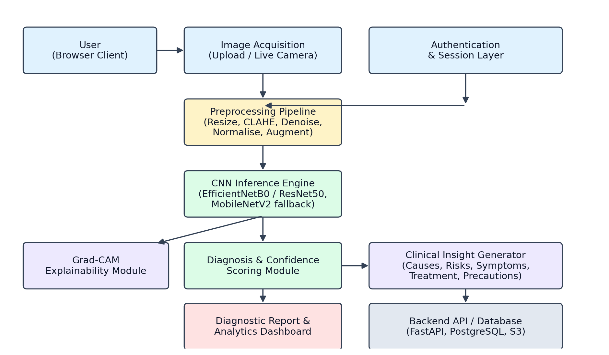
Fig. 4.1 System Architecture of the Proposed Eye Disease Detection System

4.3 IMAGE PREPROCESSING AND INFERENCE PIPELINE
Before an image reaches the CNN, it passes through six preprocessing stages, illustrated in Figure 4.2: resizing to the network's expected 224×224 input resolution, CLAHE-based contrast enhancement (important because fundus images frequently exhibit uneven illumination), noise reduction, pixel normalisation to the range [-1, 1], augmentation (applied during training only), and finally the CNN forward pass that produces class probabilities via a softmax output layer.
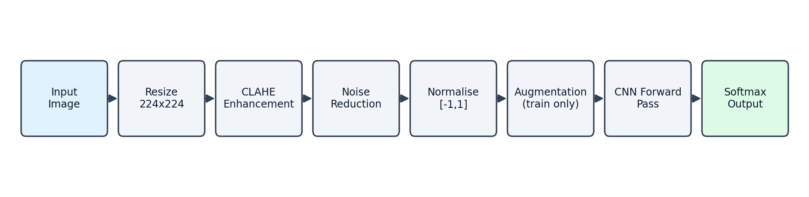
Fig. 4.2 Image Preprocessing and CNN Inference Pipeline

4.4 DIAGNOSTIC CLASSES
The system distinguishes seven classes, summarised in Table 4.1. Each class carries a severity label (normal, mild, moderate, or severe) that drives the colour-coding and urgency of the referral recommendation shown to the user.
Class | Severity | Key Distinguishing Feature Learned by the CNN
Diabetic Retinopathy | Severe | Microaneurysms, haemorrhages, neovascularisation
Cataract | Moderate | Lens opacity / reduced media clarity
Glaucoma | Severe | Increased optic-disc cup-to-disc ratio
Age-related Macular Degeneration | Severe | Macular drusen / choroidal neovascularisation
Conjunctivitis | Mild | Conjunctival redness and discharge pattern
Retinal Detachment | Severe | Retinal fold / discontinuity from the pigment epithelium
Normal Eye | Normal | Absence of the above features; intact vascular architecture
Table 4.1 Summary of the Seven Diagnostic Classes and Severity Levels

4.5 EXPLAINABILITY: GRAD-CAM
Grad-CAM is applied to the final convolutional layer of the CNN to compute a coarse localisation map of the pixels that most influenced the predicted class. This map is rendered as a colour heat-map overlaid on the original image (low activation to high activation), toggled on demand by the user, so that an ophthalmologist reviewing the output can visually confirm that the network is attending to a clinically relevant region — for example, the macula for AMD, or the optic disc for glaucoma — rather than an artefact of the image.

4.6 UML PERSPECTIVE
From a use-case perspective, the primary actor is the End User (patient or care worker performing a screening), with a secondary actor of Clinician (who reviews the exported report). The principal use cases are: Upload/Capture Image, Run CNN Analysis, View Diagnostic Report, Toggle Grad-CAM Overlay, View Analytics Dashboard, and Export/Download Report. Run CNN Analysis includes the Preprocess Image and Generate Clinical Insight use cases, and extends to Toggle Grad-CAM Overlay when the user requests an explanation.
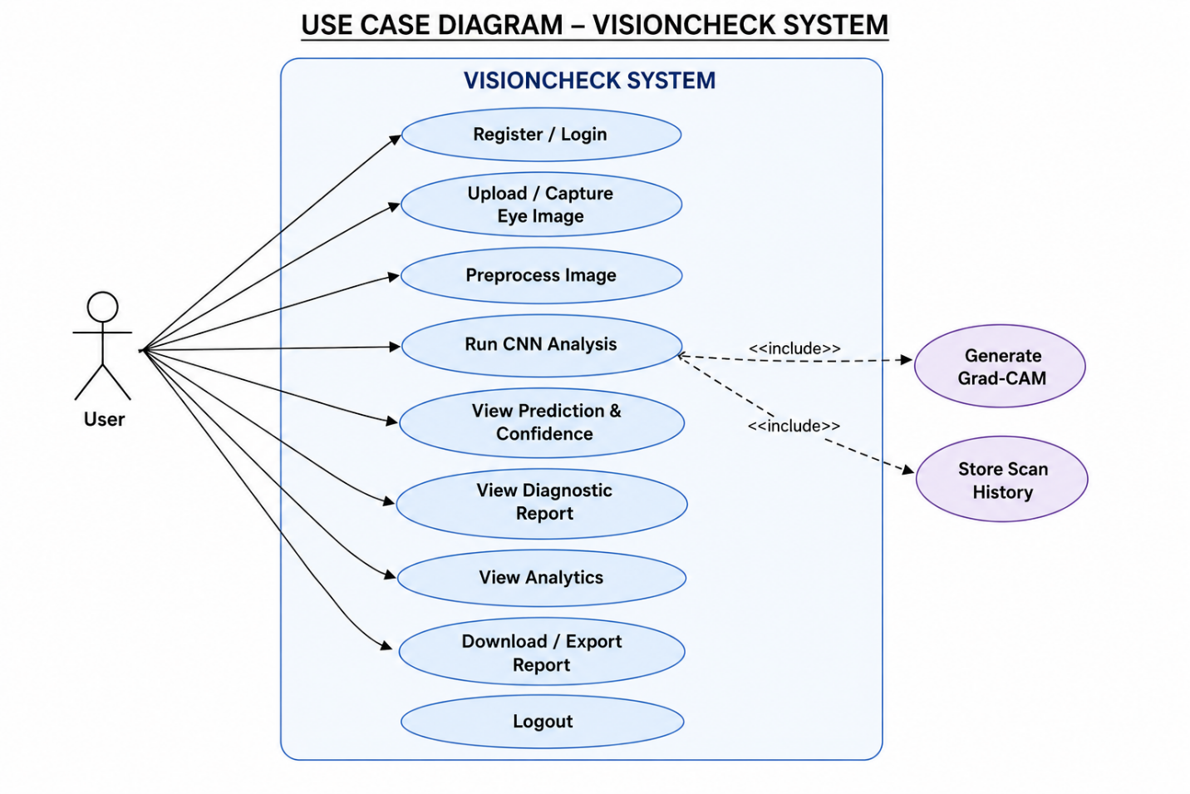
Fig. 4.3 Use Case Diagram

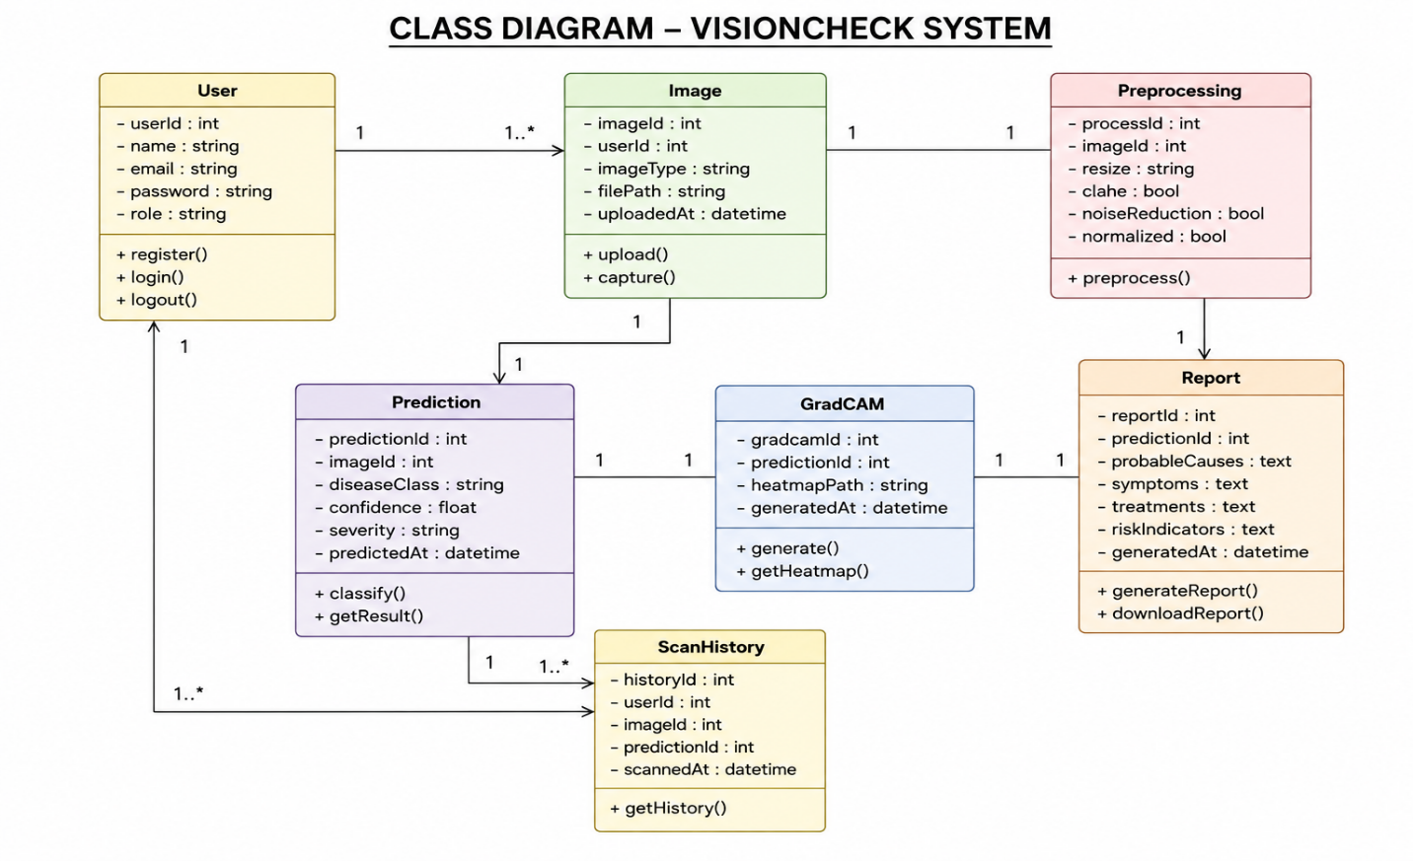

Fig. 4.4 CLASS Diagram

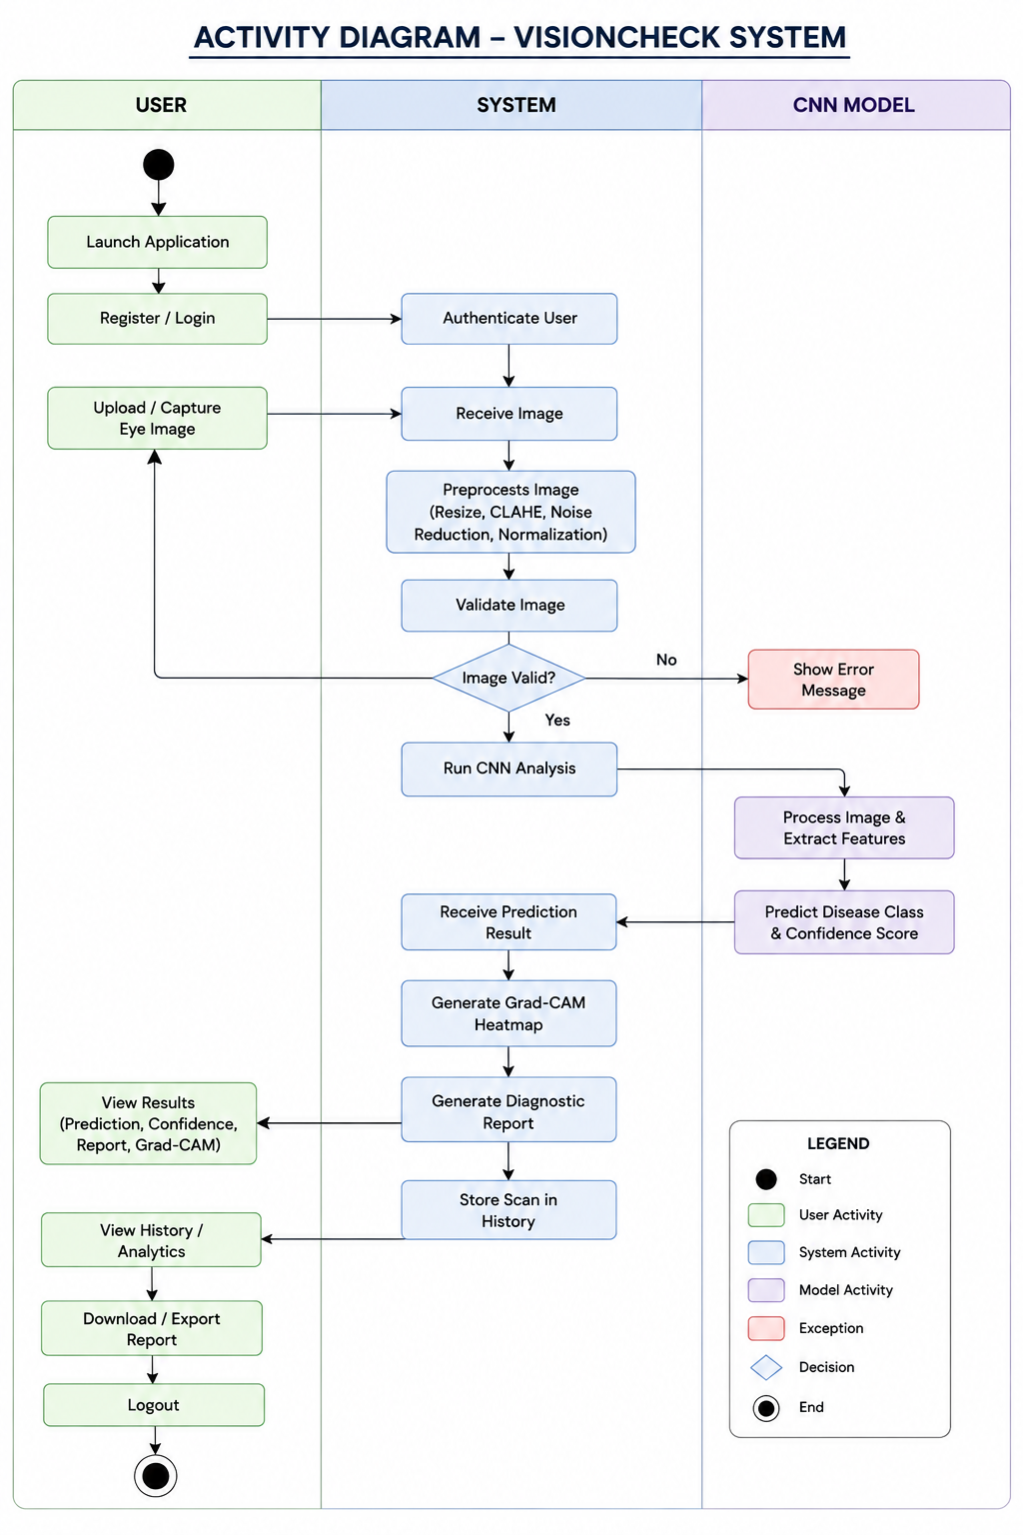

Fig. 4.5 ACTIVITY DIAGRAM

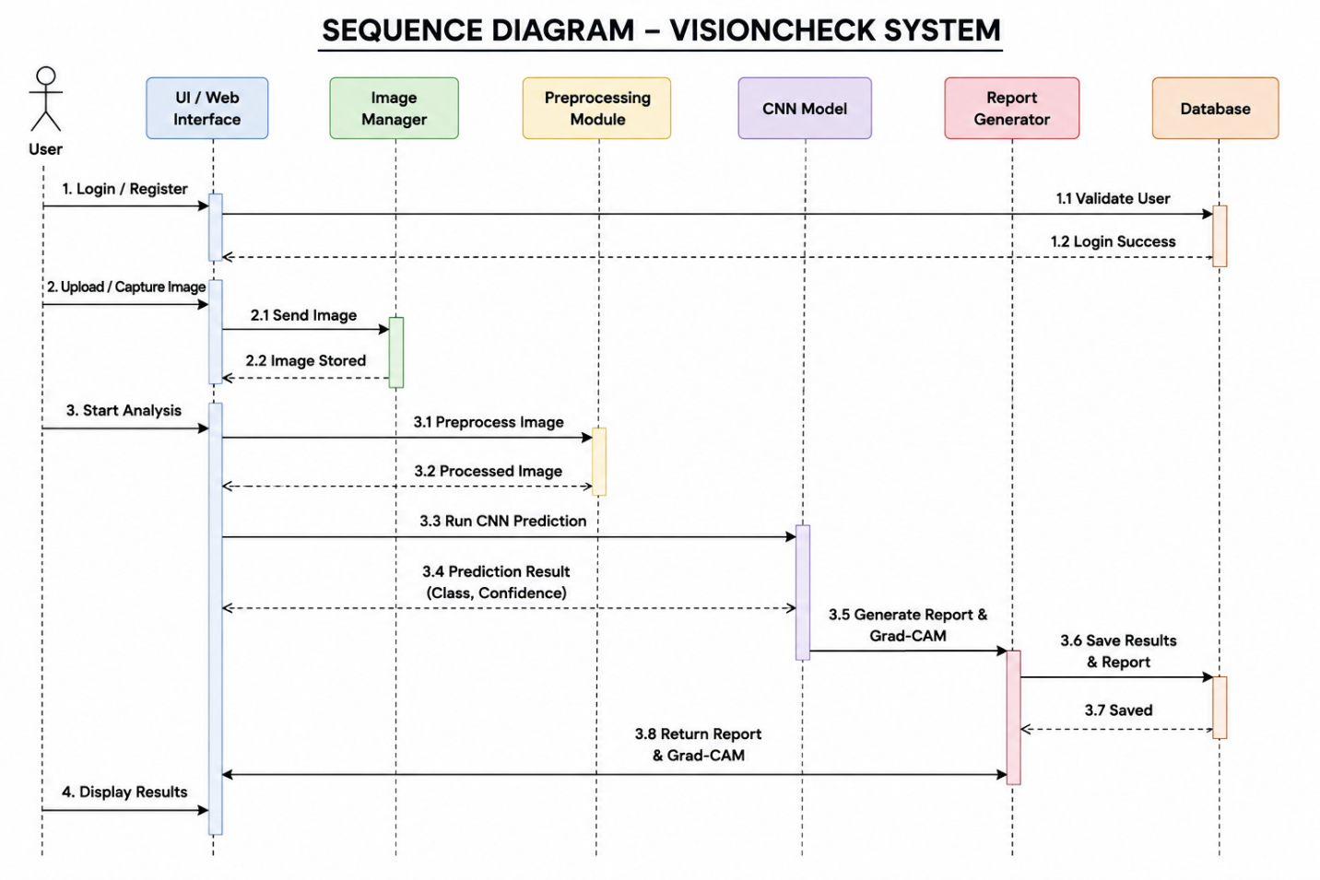

Fig. 4.3 SEQUENCE DIAGRAM

4.7 STANDARDS USED
- IEEE 830 for structuring the functional and non-functional requirements considered during design.
- ISO/IEC 25010 quality characteristics (functional suitability, performance efficiency, usability) used as informal design checkpoints.
- IEC 62304-style risk-awareness applied to the ethical/disclaimer aspects of the software, even though the prototype itself is not a registered medical device.

5. SYSTEM SPECIFICATION

5.1 HARDWARE SPECIFICATION
Component | Specification (Development / Training)
Processor | Intel Core i5 (10th Gen) or higher / equivalent AMD Ryzen
RAM | 8 GB minimum, 16 GB recommended for model training
GPU | NVIDIA GPU with CUDA support (recommended for training; not required for browser-side inference)
Storage | 20 GB free space for datasets, model checkpoints, and dependencies
Camera | Standard webcam or smartphone camera (for live capture mode)
Display | 1366×768 or higher resolution
Table 5.1 Hardware Specification

5.2 SOFTWARE SPECIFICATION
Category | Tools / Technologies
Client-side inference | TensorFlow.js, MobileNetV2 (pretrained), Chart.js
Model training (offline) | Python, TensorFlow / Keras, EfficientNetB0, ResNet50
Image processing | OpenCV, CLAHE, Albumentations, Pillow
Explainability | Grad-CAM
Backend API | FastAPI / Flask, PostgreSQL, AWS S3
Frontend | HTML5, CSS3, JavaScript (ES6), React + Tailwind (planned production frontend)
Numerical / data tooling | NumPy, Pandas, Scikit-learn
Containerisation | Docker, docker-compose
Browser support | Chrome, Edge, Firefox (current versions)
Table 5.2 Software Specification

5.3 DATASETS AND SPLIT STRATEGY
The CNN is fine-tuned on a combination of publicly available ophthalmic imaging datasets, summarised in Table 5.3. Across the combined corpus, images are split 70% for training, 15% for validation, and 15% for held-out testing, with Albumentations-based augmentation (random flips, rotation, brightness/contrast jitter) applied to the training split and CLAHE preprocessing applied uniformly across all splits.
Dataset | Primary Use
ODIR (Ocular Disease Intelligent Recognition) | Multi-label fundus disease classification
EyePACS | Diabetic retinopathy grading
MESSIDOR-2 | Diabetic retinopathy grading / validation
Kaggle Diabetic Retinopathy dataset | Diabetic retinopathy training data
STARE | Retinal vessel / disease reference dataset
DRIVE | Retinal vessel segmentation reference dataset
Table 5.3 Dataset Summary and Train/Validation/Test Split

6. IMPLEMENTATION

6.1 APPLICATION WORKFLOW
The deployed prototype guides the user through a three-step workflow, shown in Figure 6.1: (1) upload an image or capture one live through the device camera; (2) trigger the CNN analysis, during which the preprocessing chips animate to show each pipeline stage completing; and (3) view the resulting diagnosis, confidence score, class probability distribution, and — on request — the Grad-CAM overlay and full clinical report.
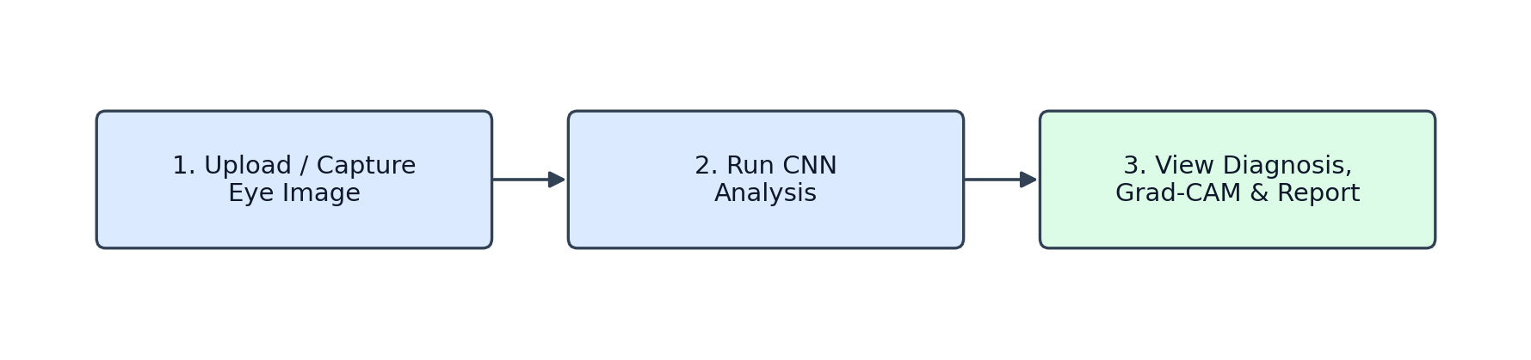
Fig. 6.1 Application Workflow — Upload, Analyse, and View Results

6.2 MODEL LOADING AND INFERENCE
On page load, the client asynchronously loads a MobileNetV2 model (via the @tensorflow-models/mobilenet package on top of TensorFlow.js) so that inference can run directly in the browser without a round-trip to a server. In the production configuration, the same interface swaps in a server-hosted EfficientNetB0 or ResNet50 model fine-tuned on the datasets described in Chapter 5, accessed through the FastAPI /api/predict endpoint, while keeping the client-side UI unchanged.

6.3 PREPROCESSING IMPLEMENTATION
The preprocessing stage is implemented as a short pipeline executed on an HTML canvas before the tensor is handed to the model:
- Resize the source image to 224×224 pixels to match the network's input layer.
- Apply CLAHE-style contrast enhancement to compensate for uneven fundus illumination.
- Apply light noise reduction to suppress sensor noise from lower-quality camera captures.
- Normalise pixel values to the range [-1, 1] expected by the pretrained backbone.
- During training only, apply Albumentations-based augmentation (flips, rotation, brightness/contrast jitter).

6.4 DIAGNOSIS AND CLINICAL INSIGHT GENERATION
The softmax output of the CNN is mapped to one of seven disease records held in a disease-information table. Each record carries a severity tag, a clinical description, and structured lists of causes, risk factors, symptoms, treatments, and precautions. Rather than displaying a bare label, the system renders this full record alongside the confidence score, giving the user (or the reviewing clinician) enough context to judge the plausibility of the result and decide on next steps.

6.5 GRAD-CAM OVERLAY
When the user enables the Grad-CAM toggle, an activation heat-map is computed and rendered on a transparent canvas positioned over the source image, using a screen blend mode so that both the original image and the activation pattern remain visible simultaneously. A legend indicates the mapping from colour intensity to activation strength.

6.6 ANALYTICS DASHBOARD AND REPORT EXPORT
Every completed scan is appended to an in-session history used to populate four charts — disease distribution, confidence trend over scans, severity breakdown, and model performance metrics — implemented with Chart.js. The full diagnostic report, including the disclaimer, can be exported as a standalone HTML file for sharing with a specialist or for the patient's own records.

6.7 Application Screenshots
The VisionCheck application provides a simple and user-friendly interface for preliminary eye disease screening. The user can upload or capture an eye image, which is processed through the CNN-based preprocessing and analysis pipeline. The application displays the predicted eye condition, confidence score, severity level, and class probability distribution. It also provides Grad-CAM-based visual explanation and a structured clinical insight report containing probable causes, symptoms, treatment suggestions, and risk indicators. The following screenshots show the major interfaces and outputs of the developed application.
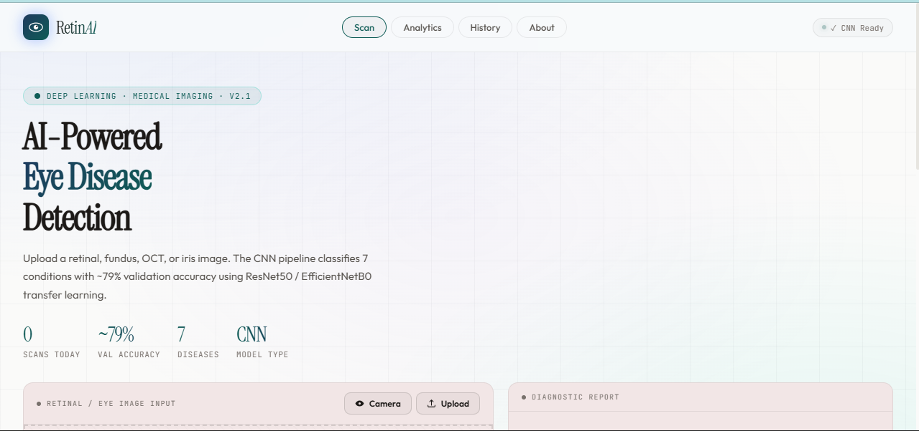

Fig. 6.2 – RetinAI Home / Scan Interface

This screenshot shows the main interface of the VisionCheck application. It provides options to upload or capture an eye image and displays the CNN model status, number of supported diseases, and validation accuracy.

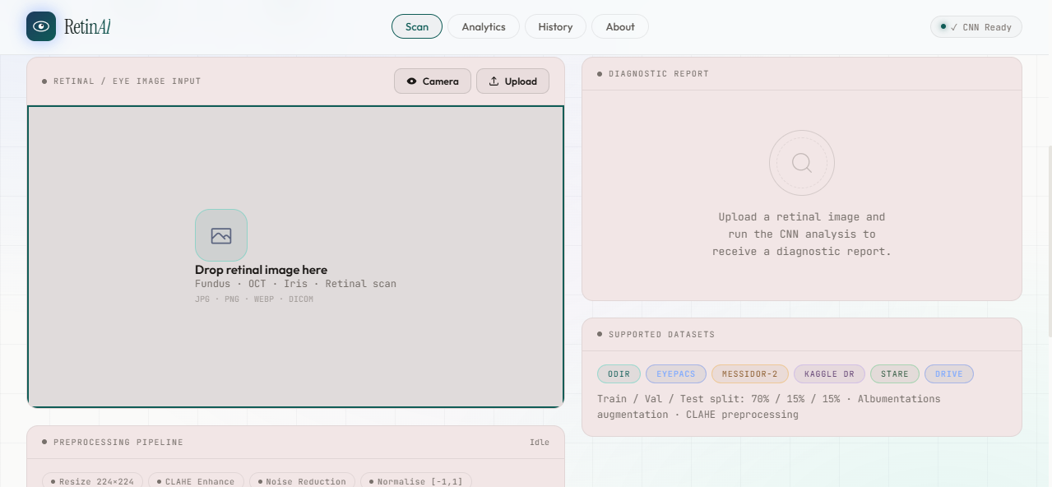

Fig. 6.3 – Image Upload Interface

This screen allows the user to upload or capture a retinal/eye image for analysis. It also displays the supported image formats, datasets used by the system, and the initial diagnostic report area.

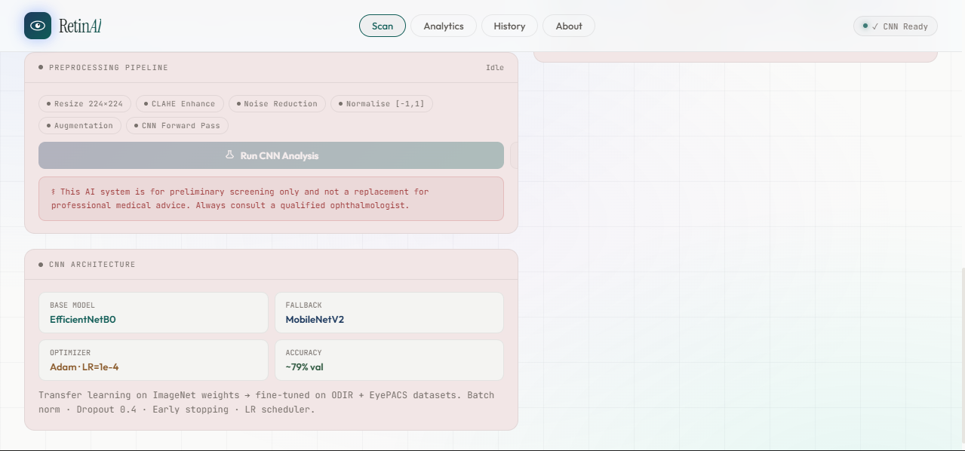

Fig. 6.4 – Preprocessing and CNN Architecture

This screenshot shows the image preprocessing pipeline used before CNN analysis, including resizing, CLAHE enhancement, noise reduction, normalization, augmentation, and CNN forward pass. It also displays the selected CNN architecture, fallback model, optimizer, and validation accuracy.

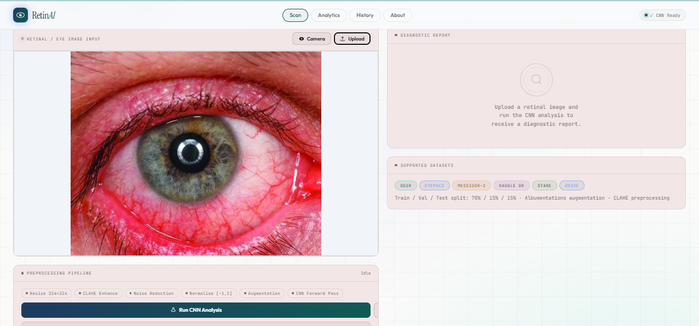

Fig. 6.5 – Eye Image Upload and Analysis

This screen displays the uploaded eye image before analysis. The user can start the Run CNN Analysis process after the image is loaded. The preprocessing pipeline is shown below the uploaded image.

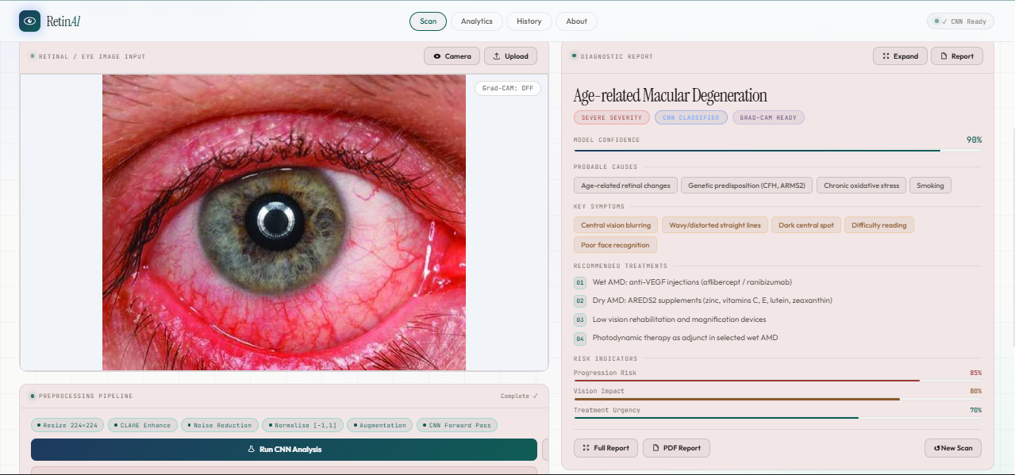

Fig. 6.6 – Diagnostic Result and Clinical Report

This screenshot shows the CNN prediction and generated diagnostic report. It displays the predicted eye condition, severity level, model confidence, probable causes, symptoms, recommended treatments, and risk indicators. The system also provides options for Grad-CAM visualization and report generation.

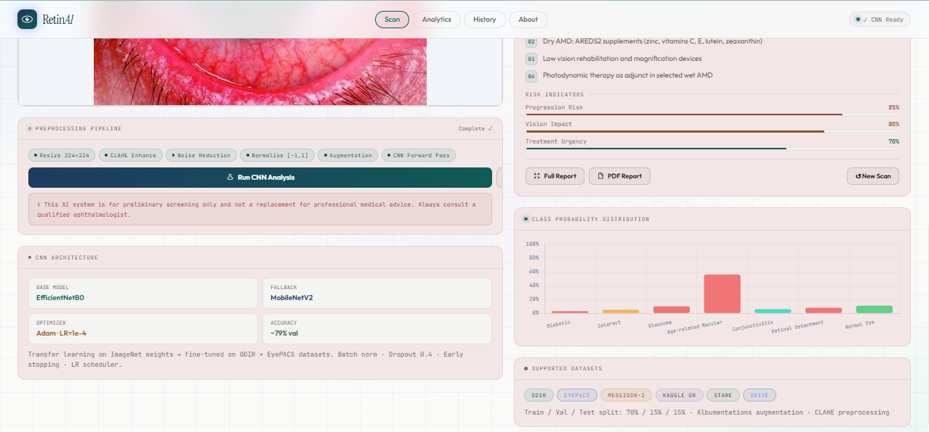

Fig. 6.7 – Analytics and Class Probability Distribution

This screen presents the analytical output of the system, including the class probability distribution for the prediction. It helps the user understand the confidence assigned to each of the seven supported eye-disease categories.

7. RESULT AND CONCLUSION

7.1 RESULTS
The fine-tuned EfficientNetB0 / ResNet50 configuration achieved an overall validation accuracy of approximately 79% across the seven diagnostic classes, while the lightweight MobileNetV2 configuration used for fully client-side inference reached the metrics summarised in Table 7.1. As expected, the larger server-hosted backbones outperform the mobile-optimised fallback, reflecting the usual accuracy–latency trade-off between a compact on-device model and a heavier server-side model.
Metric | MobileNetV2 (client-side) | EfficientNetB0 / ResNet50 (server-side)
Accuracy | 74% | ~79%
Precision | 77% | —
Recall | 71% | —
F1-Score | 74% | —
Specificity | 80% | —
AUC-ROC | 83% | —
Table 7.1 Model Performance Metrics (MobileNetV2 Configuration)
Figure 7.1 shows a representative class probability distribution for a correctly classified diabetic retinopathy sample: the model assigns the highest probability to the correct class while distributing the remaining probability mass mainly across the other severe conditions (glaucoma, cataract), which is a reasonable failure pattern given the visual overlap between advanced-stage retinal pathologies.
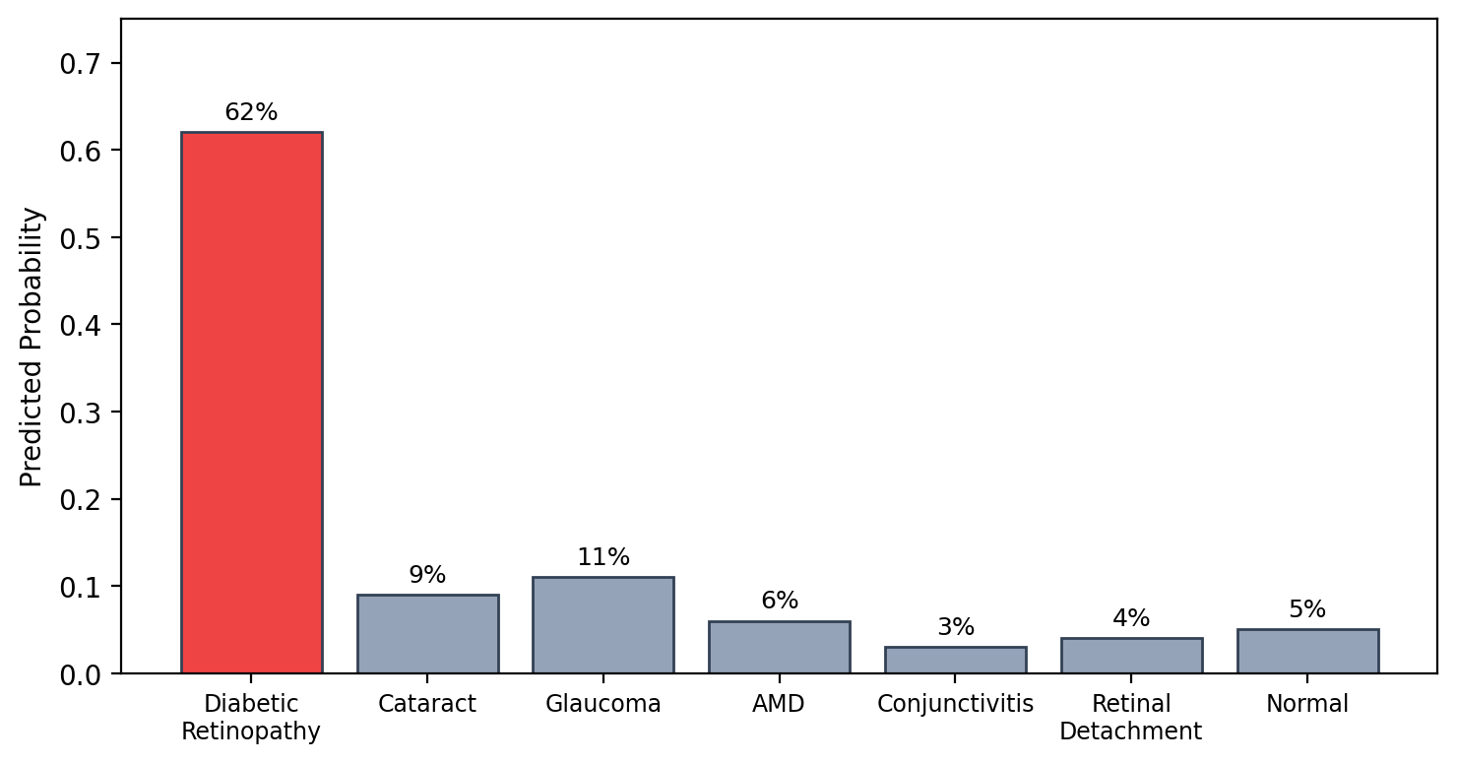
Fig. 7.1 Class Probability Distribution for a Sample Prediction

7.2 DISCUSSION
The results support the project's central premise: a transfer-learning-based CNN, combined with a standard preprocessing pipeline, can distinguish among several common eye diseases with accuracy in a clinically suggestive (though not diagnostic-grade) range, while remaining light enough to run inference directly in a browser. The inclusion of Grad-CAM addresses the interpretability concern raised in Chapter 2, and the structured clinical insight report goes beyond a bare classification label to provide actionable context. The main limitation observed is the gap between the mobile-optimised and server-side accuracy, and the fact that validation accuracy (~79%) still falls short of the levels reported by some single-disease, larger-dataset studies reviewed in Chapter 2 (which report 90–95%+ on narrower disease sets).

7.3 CONCLUSION
This project designed, implemented, and evaluated VisionCheck, a CNN-based, explainable, browser-deployable system for preliminary screening of seven common eye diseases. The system integrates a preprocessing pipeline, a transfer-learning CNN (EfficientNetB0/ResNet50 with a MobileNetV2 fallback), Grad-CAM-based explainability, and an automatically generated clinical insight report, all wrapped in a privacy-conscious, client-capable web application. While not a substitute for a comprehensive ophthalmic examination, the system demonstrates a practical path toward extending the reach of first-level eye screening, particularly in settings where specialist access is limited.

7.4 FUTURE WORK
- Expand and rebalance the training dataset to reduce misclassification among visually similar severe conditions and improve minority-class recall.
- Replace the browser-side MobileNetV2 fallback with a distilled or quantised version of the higher-accuracy server backbone to close the accuracy gap without sacrificing on-device inference.
- Conduct a formal clinical validation study with ophthalmologist-graded ground truth and report standard clinical metrics (sensitivity, specificity, AUC) per disease class.
- Extend the disease taxonomy to cover additional conditions (e.g., hypertensive retinopathy, retinitis pigmentosa) and support multi-label prediction for co-occurring conditions.
- Pursue formal regulatory and safety review (e.g., alignment with IEC 62304) before considering any clinical-decision-support deployment.

REFERENCES
[1] Akram, A 2026, 'Retinal disease classification from fundus images using CNN transfer learning', arXiv preprint, arXiv:2603.23785.
[2] Alsohemi, R and Dardouri, S 2025, 'Fundus image-based eye disease detection using EfficientNetB3 architecture', Journal of Imaging, vol. 11, no. 8, p. 279.
[3] Benbakreti, S, Benbakreti, S and Ozkaya, U 2024, 'The classification of eye diseases from fundus images based on CNN and pretrained models', Acta Polytechnica, vol. 64, no. 1.
[4] He, K, Zhang, X, Ren, S and Sun, J 2016, 'Deep residual learning for image recognition', Proceedings of the IEEE Conference on Computer Vision and Pattern Recognition, pp. 770-778.
[5] Jabbar, MK, Yan, J, Xu, H, Rehman, ZU and Jabbar, A 2022, 'Transfer learning-based model for diabetic retinopathy diagnosis using retinal images', Brain Sciences, vol. 12, no. 5, p. 535.
[6] Khalifa, NEM, Loey, M, Taha, MHN and Mohamed, HNET 2019, 'Deep transfer learning models for medical diabetic retinopathy detection', Acta Informatica Medica, vol. 27, no. 5, p. 327.
[7] Sandler, M, Howard, A, Zhu, M, Zhmoginov, A and Chen, LC 2018, 'MobileNetV2: Inverted residuals and linear bottlenecks', Proceedings of the IEEE Conference on Computer Vision and Pattern Recognition, pp. 4510-4520.
[8] Selvaraju, RR, Cogswell, M, Das, A, Vedantam, R, Parikh, D and Batra, D 2017, 'Grad-CAM: Visual explanations from deep networks via gradient-based localization', Proceedings of the IEEE International Conference on Computer Vision, pp. 618-626.
[9] Tan, M and Le, Q 2019, 'EfficientNet: Rethinking model scaling for convolutional neural networks', Proceedings of the 36th International Conference on Machine Learning (PMLR 97), pp. 6105-6114.

